**MONGO DB - 22/7/25 (Operations)**

**Theophila Murphy S**

**DE-Batch-6**

**1.insertOne()** – inserts one document

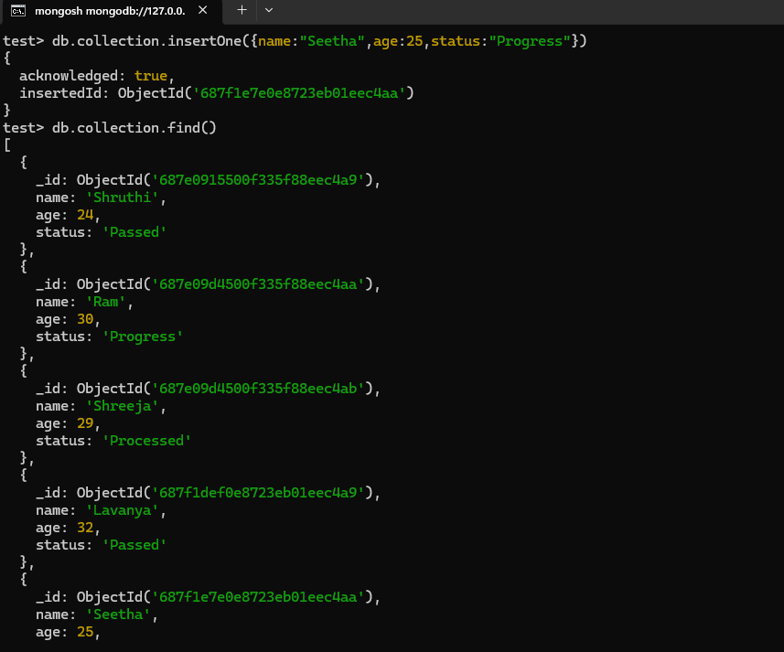

**2.insertMany() –** inserting multiple documents with [] brackets

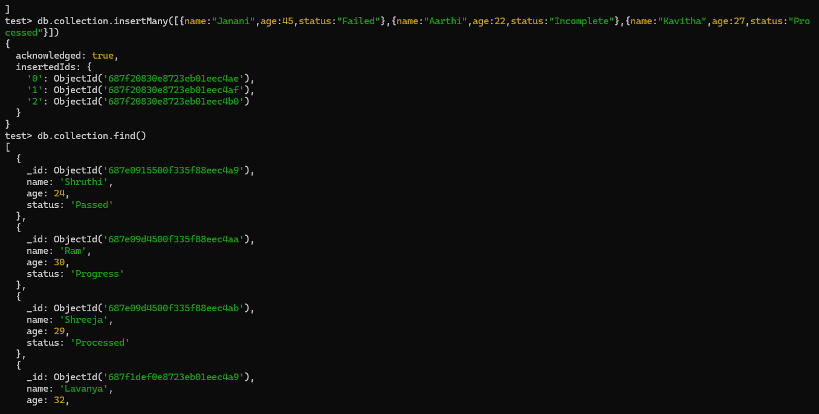

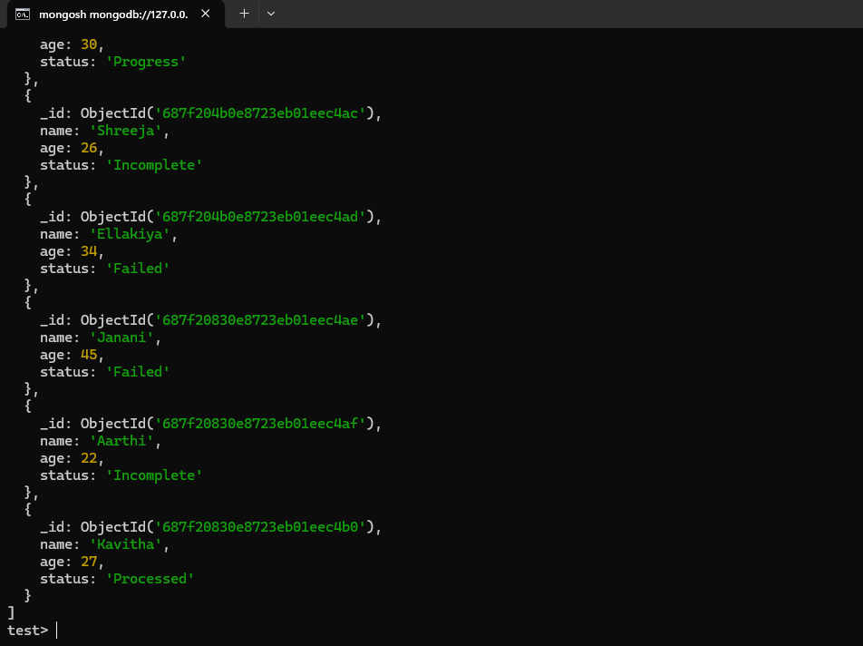

**3.updateOne()-** MongoDB is **Single atomic** so updates on document at a time.**(in single document, u can update multiple fields)**

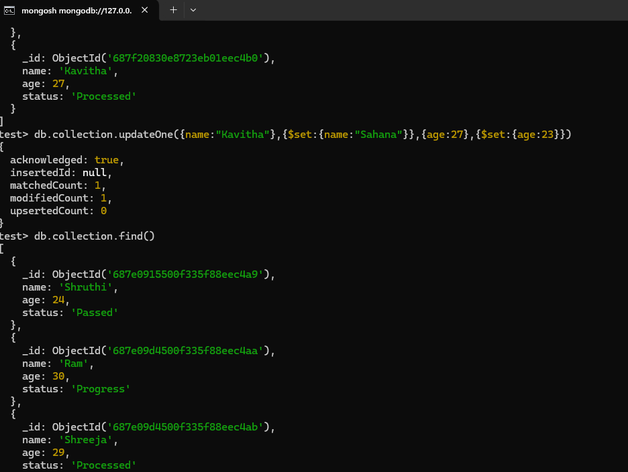

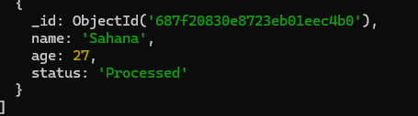

**4.updateMany()- updated the 2 documents where status is Failed to Circle Back**

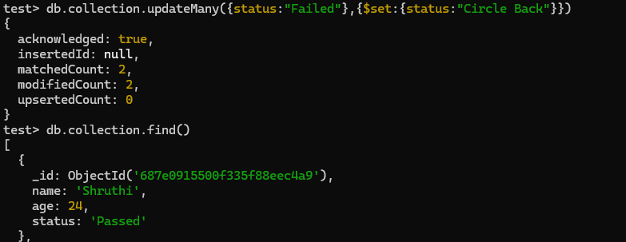

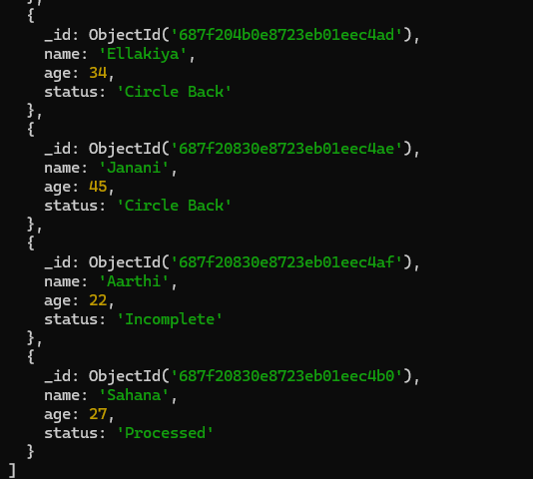

**updateMany()- On the loop is updated but the age is not updated becoz of single atomic.(2 different documents)**

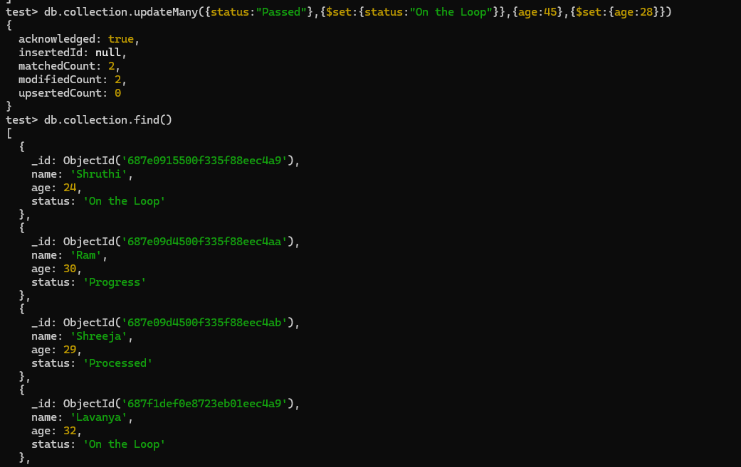

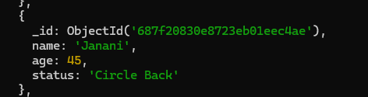

**updateMany()-Try with same document to update the status & age(only status is updated not age)**

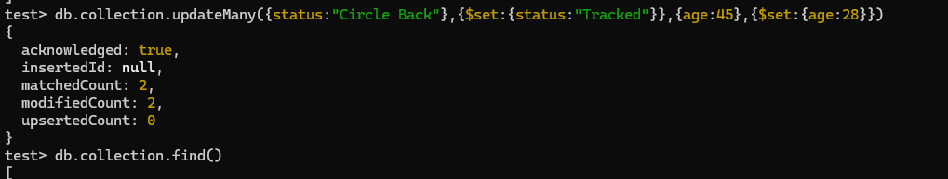

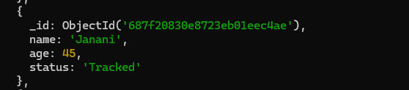

**updateMany()- The age is updated but status is not updated (update one document at a time)**

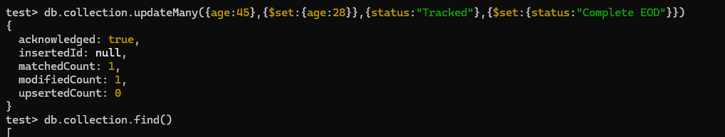

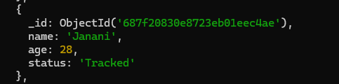

**5.deleteOne() – there was 2 tracked, one has been deleted(by executing again the another document is deleted)**

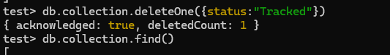

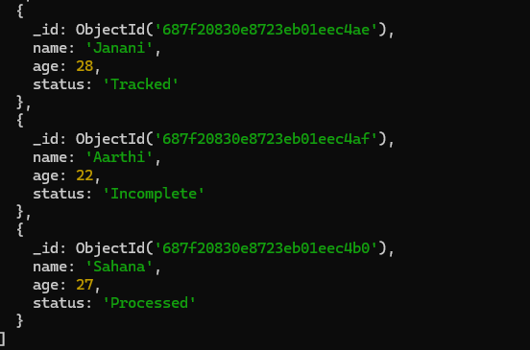

**6.deleteMany() – in this 2 documents is deleted that are status : Incomplete**

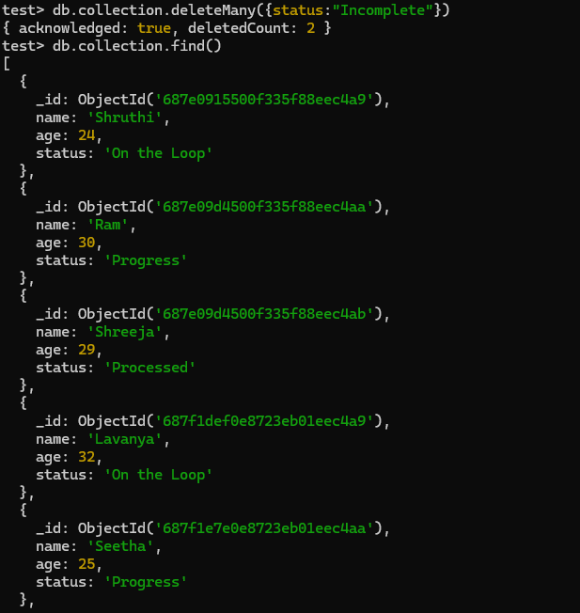

**deleteMany() – for different documents age is deleted (one document at a time is deleted)**

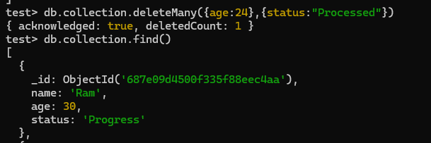

**deleteMany() -Documents contains Processed status is not deleted**

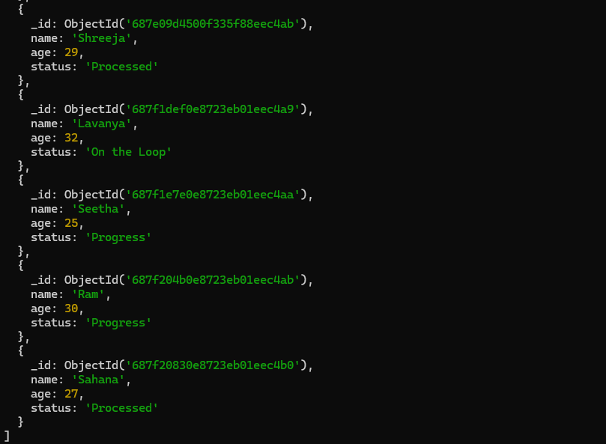

**pretty() – same like find() gives in structure**

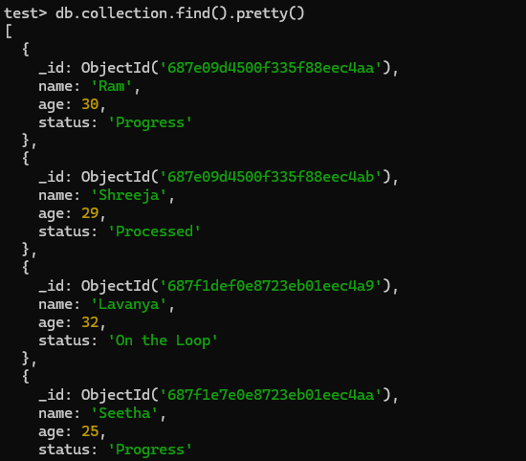

**Find().pretty() – using specific field name & age**

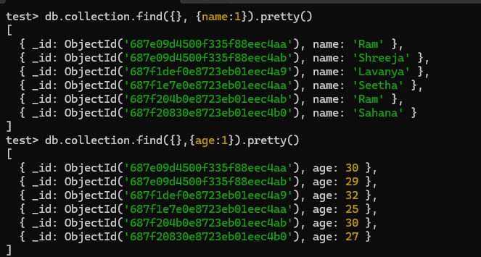

**Find().pretty() – using two fields to display. Exclude _id:0 (0 means exclusion)**

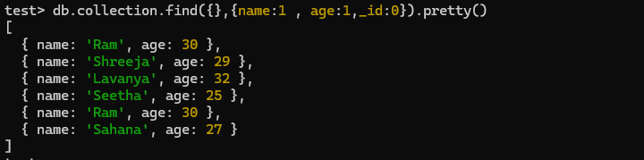

**->Projection() – specific fields is retrieved not the entire document**

**->Filter() – selects document based on filtering the fields.**